**Q I: MCQ MARKS**

1. UTP is the short form (or abbreviation) for:

a) Unfolded twisted pair

b) United twisted pair

c) Unshielded twisting particles

d) None of the above

2. _________ can impair a signal.

a) Noise

b) Attenuation

c) Distortion

d) All of the above

3. For twisted pair cables, which of the following value of “Diameter” will result in lowest attenuation?

a) .023

b) .015

c) .040

d) .020

4. Gigabit Ethernet has a data rate of……..Mbps.

a) 10

b) 100

**c) 1000**

d) 10,000

5. Currently______ is responsible for the management of internet domain names and addresses.

a) NIC

b) ICANN

c) ISOC

d) IEFE

6. If an Ethernet destination address is 07:01:02:03:04:05, then this is a ______address

a) Unicast

b) Broadcast

c) Multicast

d) None of the above

7. The _____sublayer is responsible for the operation of the CSMA/CD access method and framing.

a) LLC

b) MII

c) MAC

d) None of the above

8. In IEEE 802.11, the access method used in the PCF sublayer is……

a) Contention

b) Controlled

c) Polling

d) None of the above

9. The vulnerable time for a pure ALOHA is __________ the one for slotted ALOHA.

a) Less than

b) Greater than

c) Equal to

d) None of the above

10. If the sender is a host and want to send a packet to another host on the same network, the logical address that must be mapped to a physical address is:

a) The destination IP address in the datagram header

b) The IP address of the router found in the routing table.

c) The source IP address

d) None of the choices are correct

11. Which of the following is an example of a random_ access protocol?

a) Polling

b) FDMA

c) Token passing

d) None of the above

12. CSMA is based on the principle

a) listen before talk

b) transmit when polled

c) wait for the reservation slot

d) transmit using the assigned frequency

13. An Ethernet address is

a) 16 bits

b) 8 bytes

c) 6 bytes

d) 12 bytes

14. . ________ is a type of transmission impairment in which the signal loses strength due to the resistance of the transmission medium.

a) Distortion

b) Noise

c) Decibel

d) Attenuation

15. In a frequency-domain plot, the horizontal axis measures the ________.

a) peak amplitude

b) frequency

c) phase

d) slope

**Q II Fill in the Blanks MARKS**

**(Analog) (Digital) (Wireless)**  **(Wired) (IEEE 802.11) (IEEE 803.11)** (**FDMA)**  (**TDMA)** (**Scatternet) (Noise)(Shannon Capacity)**

1. A(n) _____________ signal has infinitely many levels of intensity over a period of time. **(Analog)**

2. Unguided communication is often referred to as _______________ communication. **(Wireless)**

3. **_____________________** formula is used to determine the data rate (or capacity) of a noisy channel. **(Shannon Capacity)**

4. IEEE has defined the specifications for a wireless LAN, called________, which covers the physical and DLL. **(IEEE 802.11)**

5. In ________, the available bandwidth of a link is shared in frequency (**FDMA)**

6. Bluetooth defines two types of networks one is piconet and the other is_________ . (**Scatternet)**

7. Twisting in a twisted-pair help reduce the________ **(noise)**

**Q. III TRUE and FALSE MARKS**

|  |  |  |
| --- | --- | --- |
| 1 | Infrared operates at a higher frequency than microwaves. | True |
| 2 | Circuit-switched network is the communication between the two ends is done in blocks of data. | False |
| 3 | In the OSI model, as a data packet moves from the lower to the upper layers (physical to application), headers are attached. | False |
| 4 | In the original ARPANET, networks were indirectly connected to each other. | False |
| 5 | Router is involved in three layers of TCP/IP protocol suite. | True |
| 6 | The data link layer of Ethernet consists of the LLC and MAC sublayer. | **True** |
| 7 | In IEEE 802.11, a station with BSS-transition mobility can move from one ESS to another. | **False** |
| 8 | The MAC sublayer uses IP addresses. | **False** |

**Q. IV Short Questions. MARKS**

1. Define the term Phase (or Phase Shift). Draw two sine waves showing 90 degrees and 180 degrees phase shifts.

**Answer:** The term phase, or phase shift, describes the position of the waveform relative to time 0.

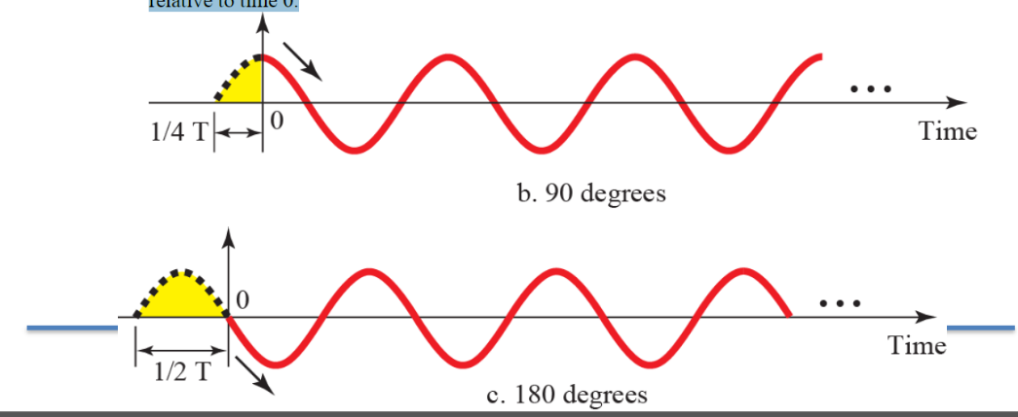

2. Write three properties for Infrared waves

Answer:

1) Waves with frequencies from 300 GHz to 400 THz

2) They are used for short-range communication

3) They cannot penetrate walls

3. Explain the difference between the two random access protocols, CSMA/CD and CSMA/CA in brief.

Ans

CSMA CD operates by detecting the occurrence of a collision. Once a collision is detected, CSMA CD immediately terminates the transmission so that the transmitter does not have to waste a lot of in continuing. The last information can be retransmitted. In comparison, CSMA CA does not deal with the recovery after a collision. What it does is to check whether the medium is in use. If it is busy, then the transmitter waits until it is idle before it starts transmitting. This effectively minimizes the possibility of collisions and makes more efficient use of the medium.

**Q. V Long Question. MARKS**

Below is the representation of three sine waves in frequency domain (Figure b). Draw a similar Figure representing the same three signals in the “Time Domain.” Note that only one Figure/Diagram should be drawn as your answer.



Answer:

